# DREAM HOMES REALTY



**INTODUCTION**

**OVERVIEW**:

Dream Home Reality is a fictitious real estate company that specializes in helping people find their ideal homes. They are known for their commitment to providing top-notch customer service, personalized property recommendations, and a wide range of real estate options, from cozy apartments to luxurious estates. Whether you're a first-time homebuyer or a seasoned investor, Dream Home Reality aims to make your property search a seamless and satisfying experience. Please note that it's not a real company but rather a hypothetical concept for this conversation.

**PURPOSE:**

The purpose of Dream Home Reality, as a fictional concept, is to serve as a model or idea for a real estate company that is dedicated to helping individuals find their dream homes. The primary goals and purposes of such a company might include:

1. Assisting Clients: To help clients find properties that align with their specific needs, preferences, and budgets, ensuring they find the perfect home.

1. Customer Satisfaction: Providing outstanding customer service to ensure that clients have a positive and stress-free experience when buying or selling real estate.
2. Personalization: Tailoring property recommendations to individual client requirements, considering factors such as location, size, style, and price range.
3. Market Knowledge: Staying updated on local real estate markets to offer clients valuable insights and advice.
4. Investment Opportunities: Assisting clients in making informed decisions when purchasing real estate for investment purposes.
5. Real Estate Expertise: Leveraging the expertise of experienced real estate professionals to guide clients through the buying or selling process.
6. Transparency: Maintaining transparency in transactions, including pricing, terms, and fees.

Keep in mind that Dream Home Reality is a hypothetical concept, and the actual purposes of real estate companies may vary based on their specific missions and business strategies.

**PROBLEM DEFINITION & DESIGN THINKING**

**EMPATHY MAP:**

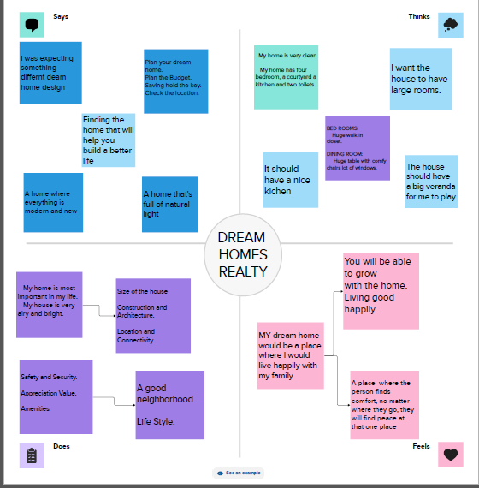

**IDEATION & BRAINSTORMING MAP:**

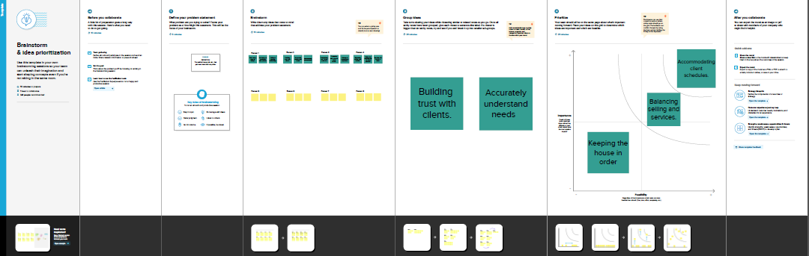

**RESULT:**

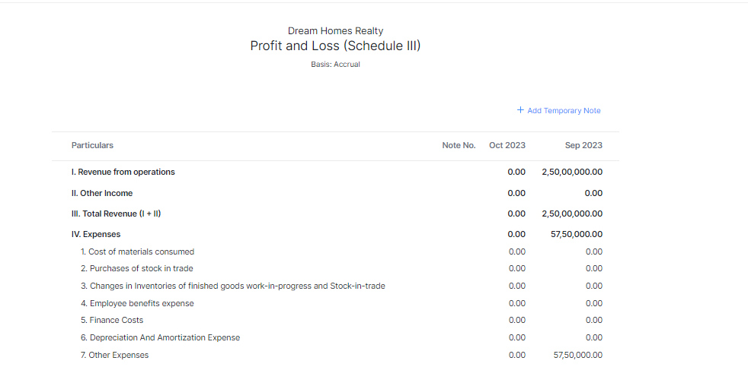







**ADVANTAGE & DISADVANTAGE:**

1. Personalized Service: Dream Home Reality can offer tailored property recommendations, taking into account clients' specific needs and desires.

2. Expertise: The company's experienced real estate professionals can provide valuable insights and guidance throughout the buying or selling process.

3. Customer Satisfaction: A commitment to top-notch customer service can lead to satisfied and loyal clients.

4. Market Knowledge: Keeping up with local real estate markets allows the company to offer informed advice to clients.

5. Client Expectations: If clients expect perfection or cannot find their dream homes, it might lead to dissatisfaction.

Remember, Dream Home Reality is a hypothetical concept, and the advantages and disadvantages listed here are based on the idea of an idealized real estate company. Real-world real estate companies can differ significantly in their offerings and services.

**CONCLUTION:**

In conclusion, Dream Home Reality serves as a conceptual model for an idealized real estate company dedicated to helping individuals find their dream homes. It emphasizes personalized service, expertise, customer satisfaction, and transparency. However, it's important to remember that Dream Home Reality is a fictional concept, and real-world real estate companies may have varying approaches and face unique challenges in delivering on these ideals. The success of any real estate company ultimately depends on its ability to adapt to market conditions, meet client expectations, and provide exceptional service within the constraints of the real estate industry.